Secure Coding Review
Code Under Review
The following Python code was reviewed to identify security issues in a simple login authentication system:
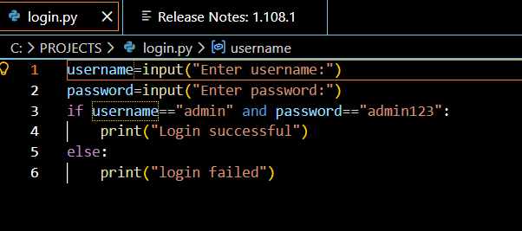
Code Review Method Used
The code review was performed using manual inspection and basic static analysis.
- Manual Inspection:
The source code was carefully read line by line to identify insecure coding practices such as hardcoded credentials and unsafe password handling.
- Static Analysis:
A basic static analysis approach was applied by checking the code against common secure coding guidelines for authentication systems, focusing on password storage, input handling, and access control logic.

Issues Identified
During the code review, the following security vulnerabilities were identified:
- Hardcoded username and password are present in the source code.
- Passwords are handled and compared in plain text.
- No restriction exists on the number of login attempts, making the application vulnerable to brute-force attacks.

Recommendations and Best Practices for Secure Coding
The following secure coding best practices are recommended:
- Avoid hardcoding sensitive information such as usernames and passwords.
- Use secure password hashing techniques instead of plain text passwords.
- Implement limits on failed login attempts.
- Follow secure authentication practices when handling user credentials.
Suggested Remediation Steps for Safer Code
The identified vulnerabilities can be addressed by taking the following remediation steps:
- Replace plain text password handling with hashed password storage.
- Store authentication details securely instead of embedding them in the source code.
- Add validation mechanisms to prevent repeated failed login attempts.
These remediation steps will improve the overall security of the application.

